

Automated Support Infrastructure Adding a Site User Guide

Table of Contents

Introduction 3
Important note about task sequence 3
Defining an ASI site record 3
Client Setup 6
Email Distribution 7
Defining a Scrip configuration 9
Activating Vs. Enabling 11
Base Scrip configuration list 11
ASI Suggested Minimum Base Follow-on Configuration 12
Defining an ASI server 13

Introduction
In order to deploy the ASI client at a new site, you need to first define a record for that site on the ASI installation server. A site record contains basic ASI client configuration information including the site name and the list of Scrips activated at the site during the start-up and follow-on phases. The entire site record set-up process takes no more than a couple of minutes for each site.
This document is a step-by-step guide for setting up a site record. For additional information about the ASI installation management facility, please refer to Automated Support Infrastructure Client Installation User Guide.

Important note about task sequence
The first time you want to install the ASI client at a new site, before you define a site record for that site, if you have not already done so, you need to define an ASI server record for your ASI server as you will have to select an ASI server for the ASI clients at the new site to log to. Please follow to the instructions in section Defining an ASI server of this document in order to define a record for your ASI server.
If you decide to activate only selected Scrips on the ASI client to be deployed at a new site, before defining a site record for the new site you will need to define a Scrip configuration for the new site which is different from the default all Scrip configuration. Please follow to the instructions in section Defining a Scrip configuration of this document in order to define a Scrip configuration that will activate selected Scrips.

Defining an ASI site record
Before installing the ASI client at a new customer site, you should do perform the following steps to define a record for that site:
- Log onto the ASI installation server at https://www.nanoheal.org/main/install/index.php with the user name and password assigned to you by HandsFree Networks.
This will take you to the Welcome page (See figure below). You are now ready to start using the ASI installation management facility.
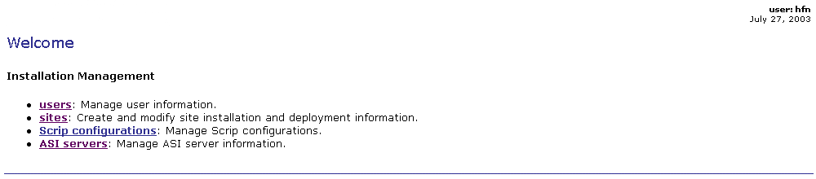
- Click on the sites link at the top right-hand corner of every page of the ASI installation management facility, or on the sites link under the Installation Management header on the Welcome page. The Sites page will be displayed (See figure below).
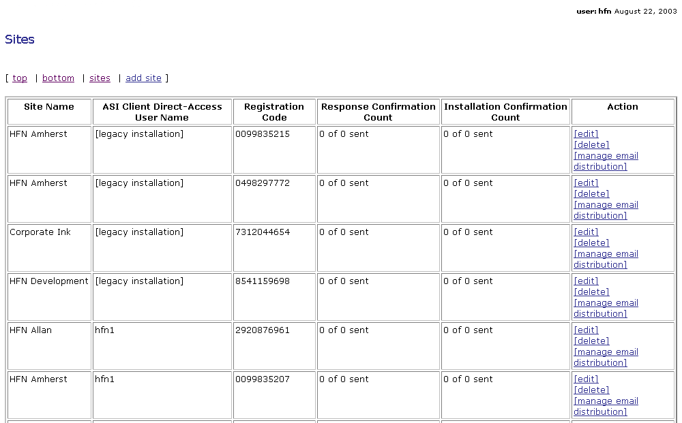
- Click on the [add site] link on the Sites page (above or below the Sites table). The Add Site Installation and Deployment Information page where you add the information for the new site will be displayed (See figure below).
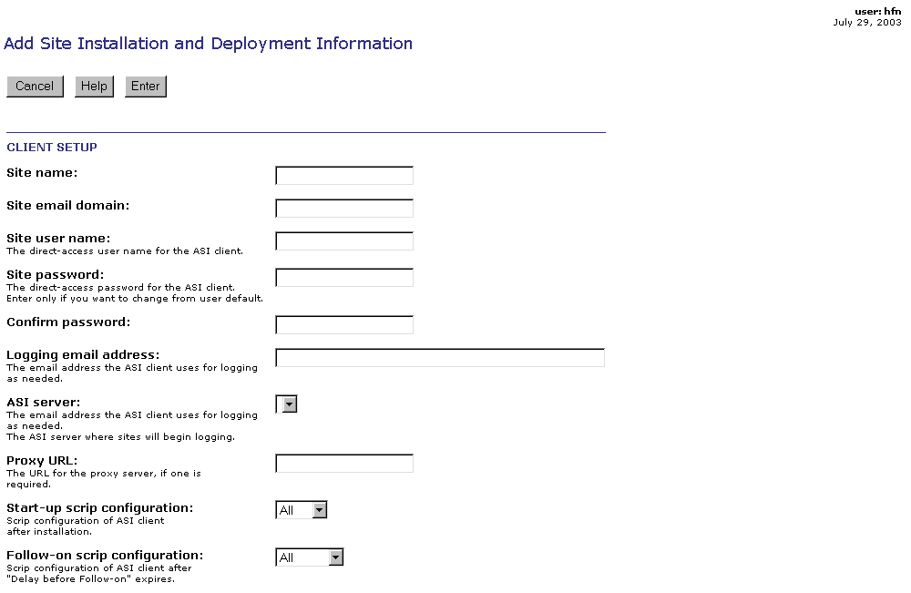
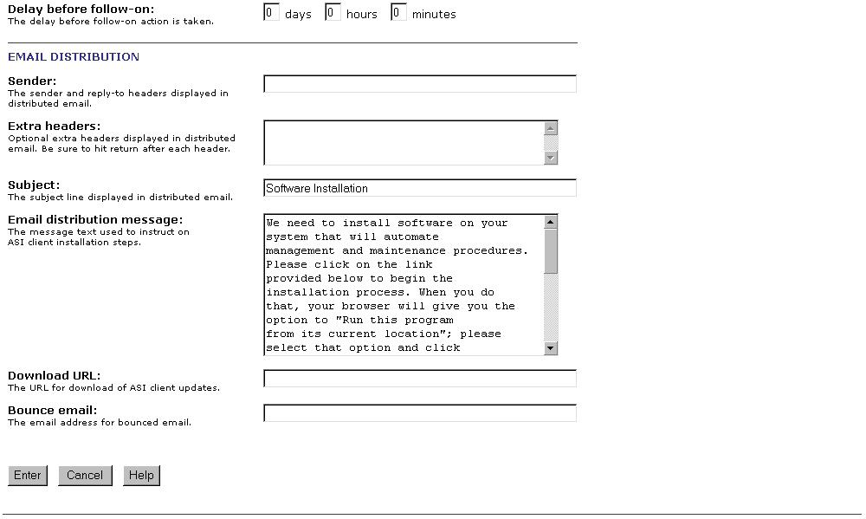
- Enter the required information as follows:

Client Setup
- Site name – the full name of the site used on the ASI server to group the logs generated by the ASI client software at the site. Spaces are allowed. The total number of characters cannot be greater than 255. When creating the name of a site you should avoid using the following characters:
- &
- , (comma)
- . (period)
For example, "Marx Brothers Inc"
- Site email domain – This is the e-mail domain name of the site. It is used by the ASI client in case it needs to communicate with the ASI server via e-mail.
- Site user name – Logged in as this user, you will be able to directly access the ASI client on any system at the site via the client browser based interface. This User name should be a single text-only string of between x and y characters. As for Server Name you should not use &, comma, or period. For ease of use, when creating a user name you might also want to avoid using upper case letters, or a mix of upper and lower case letters in user id’s.
- Site password – this should be a single text-only string of between x and y characters. For increased security, as you enter the password it is displayed as a string of *
- Confirm password – to minimize the chance of making a data entry error, you are asked to re-enter the content entered in the Password field in this field. For increased security, as you enter the password it is displayed as a string of *
- Logging email address – this is the site specific email address that is used by the ASI clients at a site when they need to directly send email to the ASI server. This is currently only used when email logging is enabled on the ASI client. By default it is not.
- ASI server – From this pull-down list you select the site specific ASI server used by ASI clients at the site. Clicking on the [edit servers] link to the right of the entry takes you to the ASI Servers page where you can edit the information for an existing ASI server or add information for another one.
- Proxy URL – If no proxy server is used at the site, leave this entry blank. If a proxy server is used at the site, please enter the site-specific address of the proxy server and the port it uses. If the proxy server at the site requires authentication, you should add a working user id and password to the proxy URL. The syntax of an entry in Proxy URL is:
- http://<user name>:<user password>@<proxy server name>:<proxy port>
Please remember that ASI requires that ports 80, 443, and 37 (time server) be left open for outbound communication.
- Start-up Scrip configuration – From this pull-down list you select the site specific Scrip configuration for the ASI client at the site, after installation is completed. The list includes all Scrip configurations defined for the user currently logged in, plus the two special options "All" and "None". The “All” configuration option enables all Scrips. The “None” configuration option puts the ASI client in dormant state for an indefinite period of time. In this state, the Scrips listed in the Base Scrip configuration list section of this document are activated and enabled. They are sufficient to let you activate the ASI client at a time of your choosing. Clicking on the [edit Scrip configurations] link to the right of the Scrip Configurations entry takes you to the Scrip Configurations page where you can edit the information for an existing list or add another one.
- Follow-on Scrip configuration – From this pull-down list you select the site specific Scrip configuration that the ASI clients at the site will use after the start-up phase is over. The list includes all follow-on options defined for the user currently logged in, plus the three special options "All", "None", and “Uninstall. The “All” configuration option enables all Scrips. The “None” configuration option puts the ASI client in dormant state for an indefinite period of time. In this state, the Scrips listed in the Base Scrip configuration list section of this document are activated and enabled. They are sufficient to let you activate the ASI client at a time of your choosing. Selecting “Uninstall” will result in removal of the ASI client from all systems where it was installed for the start-up phase. Clicking on the [edit Scrip configurations] link to the right of the Follow-on Scrip configuration entry takes you to the Scrip Configurations page where you can edit the information for an existing list or add another one.
- Delay before follow-on – in these fields you enter the site specific amount of time you want the ASI client to operate in start-up mode before moving to the follow-on phase, and applying the follow-on phase actions selected from the Follow-on Scrip configuration pull-down list. Please note that the Delay before follow-on fields have a default value of 0. Leaving the default value unchanged effectively means that the start-up and follow-on phases are one and the same.

Email Distribution
This section only applies if we are rolling the client out via e-mail distribution. Please refer to Automated Support Infrastructure Client Installation User Guide for information about the e-mail distribution function and feel free to contact HandsFree Networks for assistance.
- After you have entered and reviewed the new site information as described above click on the  button. The Adding Site page (See figure below), if the site creation operation was completed successfully, or to a page with the same name and a message explaining where the error was made.
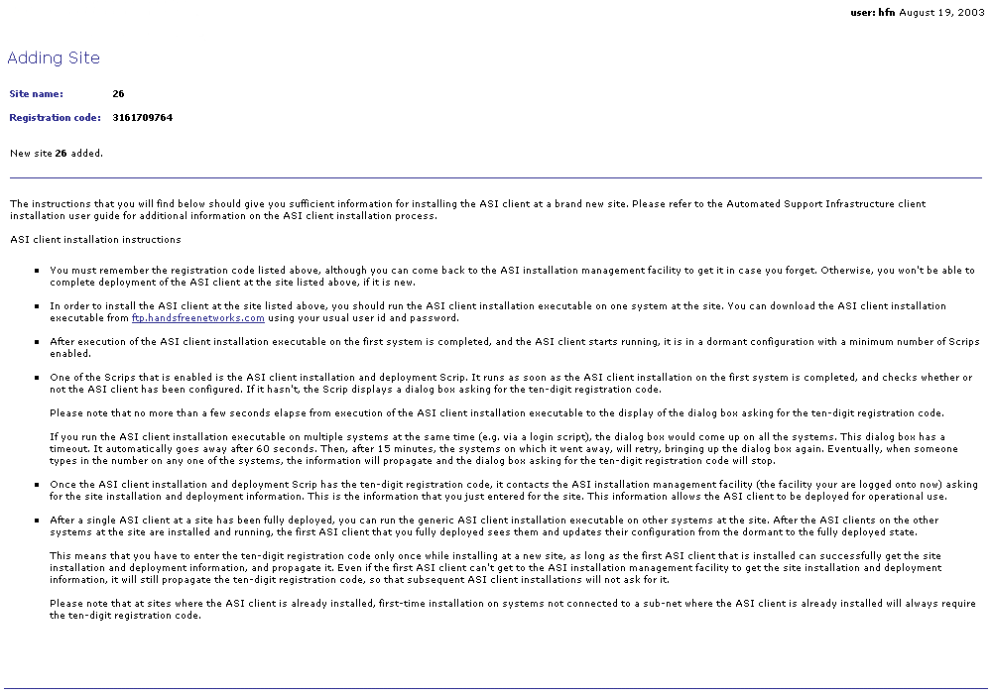
You should print out the Adding Site page as it contains the new site’s unique registration code that will be needed when installing the ASI client at the new site, and installation instructions.
- Next, click on the sites link at the top right-hand corner of the Adding Site page. The Sites page will be displayed again (See figure below).
An entry for the new site should be listed in the Sites table. Now you are ready to install the ASI client at the new site following the instructions in the Adding Site page, which you printed in step 5) above.

Defining a Scrip configuration
You can control which Scrips are enabled at each site by selecting the appropriate Scrip configuration when defining the record for a new site on the ASI installation server. In order to define a Scrip configuration record, you should perform the following steps:
- Go to the Scrip Configurations page (https://www.nanoheal.org/main/install/strtlist.php) on the ASI installation server (See figure below).
Please note that you can reach the Scrip Configurations page by clicking on the Scrip configurations link located at the top right-hand corner of every ASI installation server page to the right of the installation: label, or on the Scrip configurations link under the Installation Management header on the Welcome page of the ASI installation server.
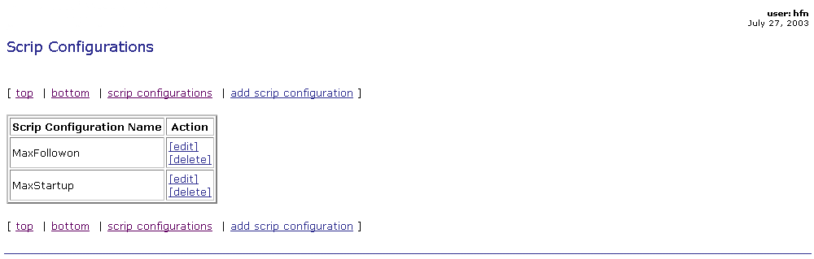

- On the Scrip Configurations page, click on the add Scrip configuration link. The Add Scrip Configuration page will be displayed (See figure below).
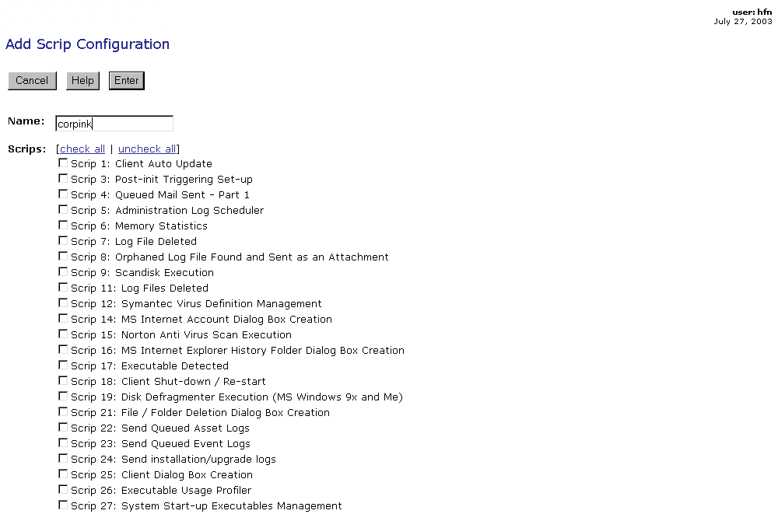

- Enter the Scrip configuration name in the box to the right of the Name: label.
- Select the Scrips you want activated when using the Scrip configuration you are defining by clicking in the box to the left of the name of each Scrip.
- Click on the button at the bottom of the page.). The Adding Scrip Configuration page will be displayed (See figure below).
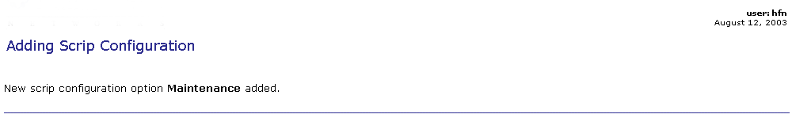
Please note that regardless of your selection on the Scrip Configurations page, Scrips, included in the Base Scrip Configuration list below, will always be enabled.

Activating Vs. Enabling
If you selected the None Scrip configuration in step 4) in the Client Setup section above, you would expect that no Scrips be active when you install the ASI client. Yet, if you check the Scrip configuration page of any system either directly on any ASI client at the site, or on the server by going to the configuration module (https://asiserverurl/main/config/index.php), you will see that ALL Scrips are enabled.
What is going on?
Enabling a Scrip via its configuration page, means that when the Scrip runs it checks its enable option and if it finds it disabled, it will not perform its action(s).
Not activating a Scrip by not selecting as part of a site’s start-up or follow-on Scrip configuration means that the ASI client will not even attempt to run the Scrip. This means that the Scrip will not get to the point of checking whether it is enabled or not.
For your convenience, we have enabled the enable option for all Scrips so that when you decide to activate them, you will not have to also go to their configuration page and enable the enable option.
In order to activate a Scrip you have to enter its number in the Scrips enabled at start-up, and/or the Scrips enabled at start of follow-on phase parameters in the Scrip 223 configuration page. Note that Scrips can be activated for an entire site or of individual systems at a site.

Base Scrip configuration list
- Scrip 1 – Client update
- Scrip 2 – Variable propagation
- Scrip 177 – Client/server variable synchronization
- Scrip 190 – Run as a service
- Scrip 186 – Scrip run limit (start multithreaded operation)
- Scrip 187 – Fill machine name cache
- Scrip 43 – Basic ASI client configuration
- Scrip 223 – ASI client initial setup (from generic installation)
- Scrip 18 – ASI client restart/shutdown
- Scrip 63 – Log ASI client startup
- Scrip 64 – Log ASI client shutdown
- Scrip 201 – ASI network driver management
- Scrip 248 – Registry Device Driver Management
- Scrip 99 – Debug
- Scrip 226 – CApp management
Initially, we would advise that the All Scrip configuration option be selected in step 4) in the Client Setup section above. However, if you wish to select a more limited set of Scrips to activate at the start of the follow-on phase, you could define a Scrip configuration to activate the Scrips contained in the ASI Suggested Minimum Base Follow-on Configuration list below. This list includes all of the maintenance, monitoring, ASI administration, and selected system management Scrips. The Scrips in the list were selected to enable you to provide timely support, perform useful routine maintenance, provide essential troubleshooting information, and let you perform important system management tasks.

ASI Suggested Minimum Base Follow-on Configuration
Please note that the suggested minimum configuration listed below does not include any of the intrusion protection, and malware protection management functions, nor a number of problem resolution and management Scrips.
Scrip 22 – Asset logging
Scrip 23 – Event logging
Scrips 50 and 51 – Process start and completion
Scrip 61 – System survey
Scrips 12, 15, 90, 175, 242, 243, 247, 249, 238, 239, 244, and 250 – Symantec, MacAfee, CA Etrust, and Trend Micro virus scans and virus definition management
Scrips 60 and 69 – Temp files and chkdsk files clean-up
Scrips 19, 92, 211 – Disk defragmentation
Scrips 68, 86, and 87 – Date and time change management, clock synchronization, slow clock reset
Scrips 65 – ASI client error reporting (important)
Scrips 231 – ASI client heartbeat (important)
Scrip 95 – Disk capacity statistics
Scrip 6 – Memory statistics
Scrip 96 – Processor statistics
Scrip 97 – Disk performance statistics
Scrip 70, 71 – Software installations and removals
Scrip 73 – System restart
Scrip 74 – Printer installation and removal
Scrip 77 – Windows event log changes
Scrip 89, 151-157, 212-215 – Program execution
Scrip 94 – Dialog box detection
Scrip 176 – Services restart
Scrip 196 – Patch deployment (insurance policy for emergency patch deployment)
Scrip 227 – Process and service shutdown/restart
Scrip 225 – File and directory change detection and prevention
Scrip 236 and 245 – Remote control function using UltraVNC and Citrix GoToAssist respectively.
Scrip 237 – Microsoft Update Management
Scrip 100 – File distribution and retrieval (very useful, highly recommended)

Defining an ASI server
In order to have the ASI clients at your sites log event and asset logs, and let you manage and update them remotely, you need to make sure that information about your ASI server is entered in each ASI client base configuration.
This means that each site record needs to have information about your ASI server. You do this be defining a record for your ASI server which you then select as the value for the ASI server parameter as described in step 4) in the Client Setup section above.
In order to define an ASI server record you should perform the following steps:
- Go to the ASI Servers page (https://www.nanoheal.org/main/install/servlist.php) on the ASI installation server (See figure below).
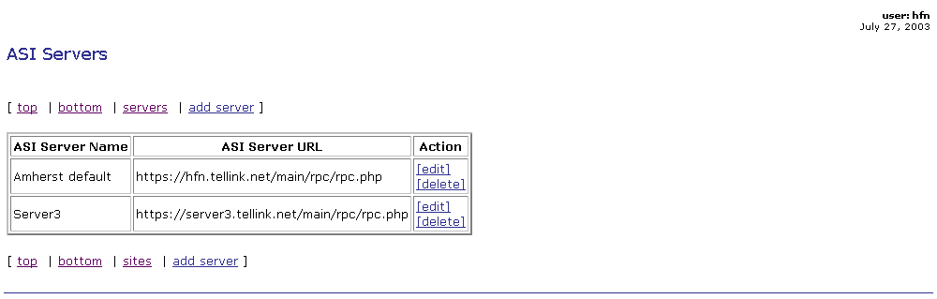
Please note that you can reach the ASI Servers page by clicking on the ASI servers link located at the top right-hand corner of every ASI installation server page to the right of the installation: label, or on the ASI servers link under the Installation Management header on the ASI installation server Welcome page.

- On the ASI Servers page, click on the add server link. The Add ASI Server Information page will be displayed (See figure below).
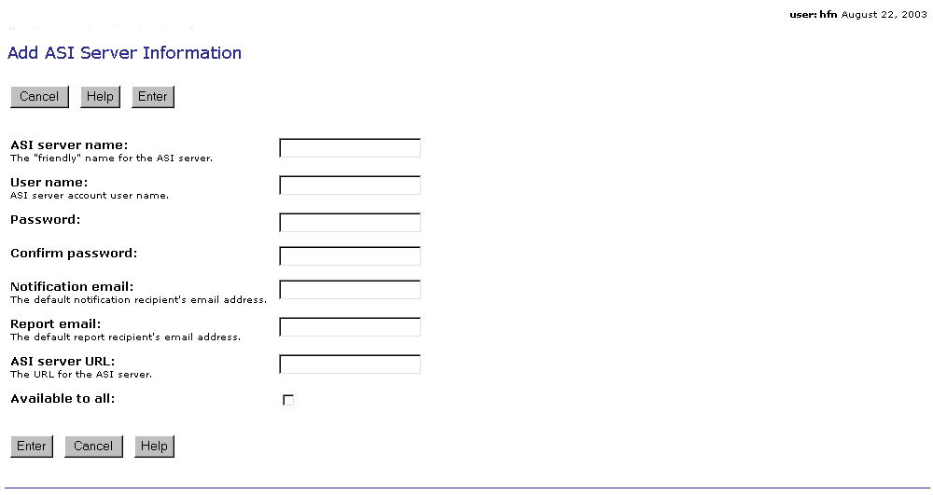
- Enter the required information as follows:
- Server Name – the “friendly” name of the ASI server should be a single text string of up to 50 characters in length. When creating the “friendly” name of an ASI server you should avoid using the following characters:
- &
- , (comma)
- . (period)
- User name – this is the name of the user that will have access to the site’s event, asset, and site management facilities on the ASI server. It should be a single text-only string of between x and y characters. As for Server Name you should not use &, comma, or period. For ease of use, when creating a user name you might also want to avoid using upper case letters, or a mix of upper and lower case letters in user id’s.
- Password – this should be a single text-only string of between x and y characters. For increased security, as you enter the password it is displayed as a string of *
- Confirm Password – to minimize the chance of making a data entry error, you are asked to re-enter the content entered in the Password field in this field. For increased security, as you enter the password it is displayed as a string of *
- Notification email – in this field, enter the e-mail address(es) of the recipient(s) of notifications sent via e-mail. Multiple addresses should be separated by commas. For example: groucho@marxbrothers.com,chico@marxbrothers.com
- Report email – in this field, enter the e-mail address(es) of the recipient(s) of reports produced for the site. Multiple addresses should be separated by commas. For example: harpo@marxbrothers.com,zeppo@marxbrothers.com
- ASI Server URL – Here you enter the URL for the ASI server. For example:, https://asiserverurl:443/main/rpc/rpc.php
Substitute asiserverurl with the URL of the ASI server your sites log to.
To test whether the URL you entered for the ASI server is correct, perform the following steps:
- Open a new browser window
- Copy the ASI server entry in the box to the right of the ASI Server URL – label and click on the Enter key on your keyboard
- If the ASI server URL is correct, a page with the following message should be displayed:
The XML page cannot be displayed
Cannot view XML input using XSL style sheet. Please correct the error and then click the Refresh button, or try again later.

The stylesheet does not contain a document element. The stylesheet may be empty, or it may not be a well-formed XML document.

- Available to all – If selected, this option makes the ASI server whose information you are entering, or editing, available as a possible ASI server selection to all sites whose record is created, or accessible, by the currently logged in user.
- Click on the button found both at the top of the page under the page title, and at the bottom of the page. The Adding ASI Server page will be displayed (See figure below).
